Delivery Hub Replacement Project

Contents

LOGIN 4

Step 1: Login 4

# 

# LOGIN

#### Example Screen:

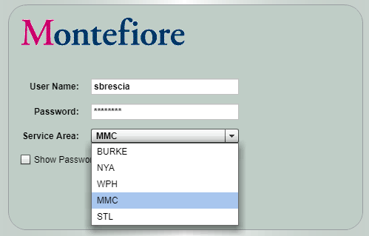

* **Use your Montefiore Active Directory network login and password**
* **Users must be registered with EDI Systems to gain access**
* **Admin users are assigned to ALL Facilities – Facility users will only see their applicable Facility(s)**
* **Roles are assigned to each user to determine what tabs and data are available to that user**

# Top Level Tabs

#### Example Screen:

## 



* **A user’s roles determine what tabs are available**
* **Claims** – 837I and 837P files and processes
* **Remits** – 835 files and processes
* **Interfaces** – Real-time view of batch interface status
* **Admin** – reserved for administrators (will not be covered here)
* **“User’s Tab”** – A tab that displays a chronological listing of Delivery Hub pickups with their associated deliveries.
  + Provides direct access to every pickup/delivery regardless of “Process”
  + Customizable for the user’s preferences

# Date Filter

#### Example Screen:

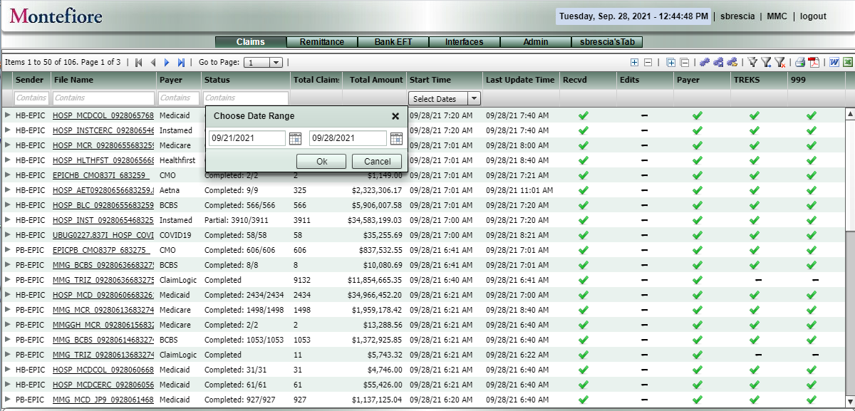

**Date Filter**

1. **Choose “Select Dates”**
2. **Select Start & End dates**
3. **Click OK**

# Date Filter – Cont.

#### Example Screen:

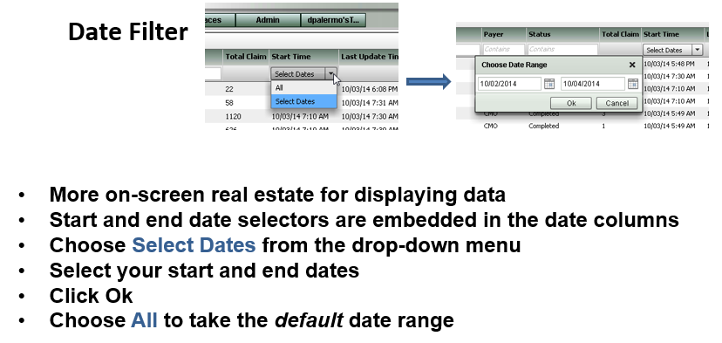

# Auto-Filter Text Boxes & Page Navigation Buttons

#### Example Screen:

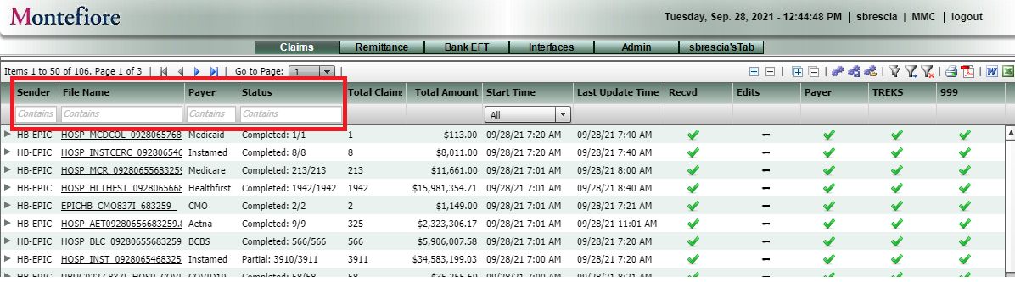

**Auto-Filter Text Boxes - Type any text and the results will automatically filter to match your text as you type.**

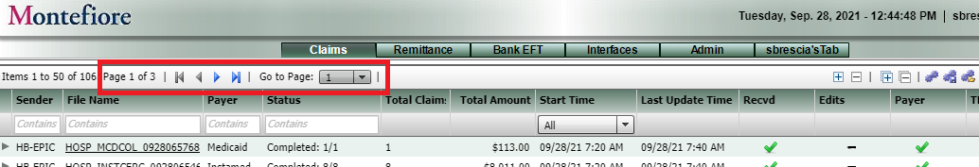

**Page Navigation Buttons**

# Export to PDF, Word, Excel and Status Indicators

Example Screens

#### :

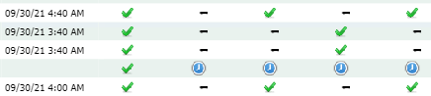

# Claims Tab

#### Example Screen:

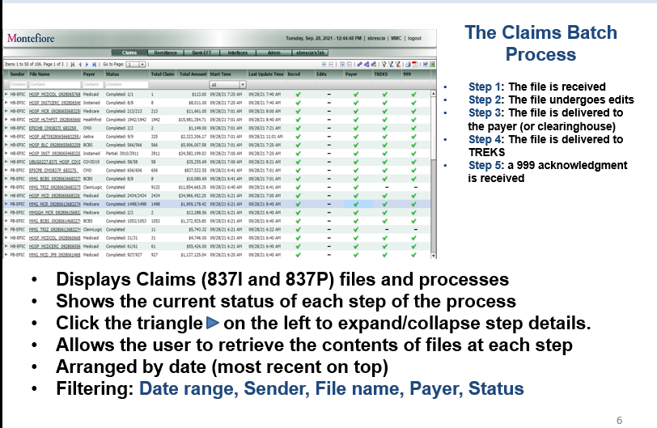

# Triangle (on left) to Expand/Collapse Step Details

#### Example Screen:

# 

# File Viewer

#### Example Screen:

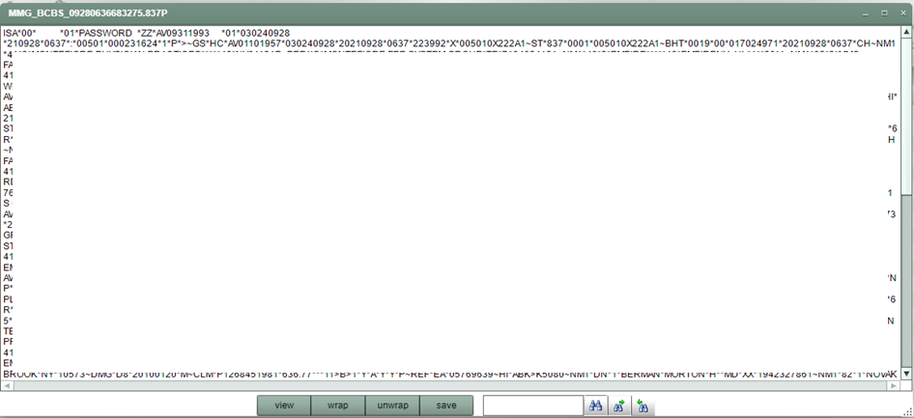

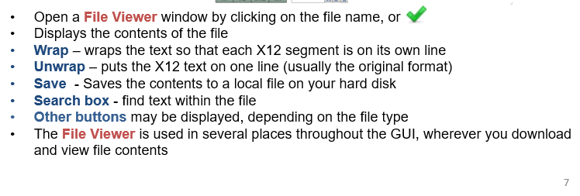

# File Viewer - WRAP

#### Example Screen:

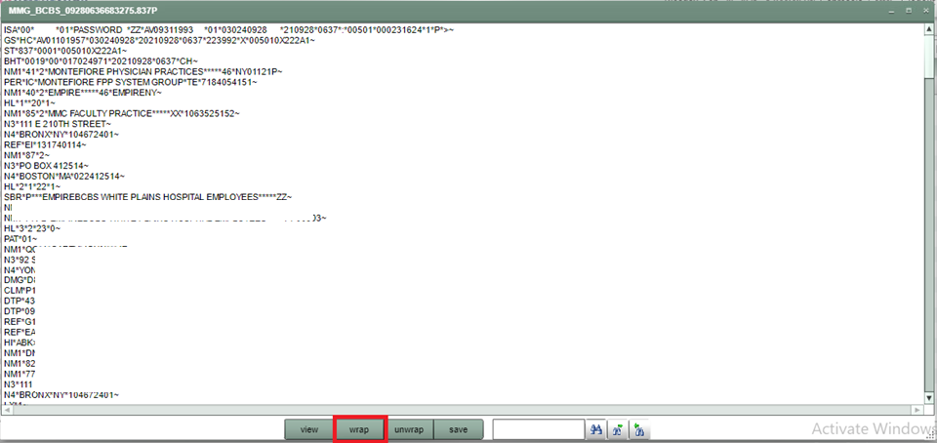

* **Wrap** – wraps the text so that each X12 segment is on its own line

# The Remits Tab

#### Example Screen:

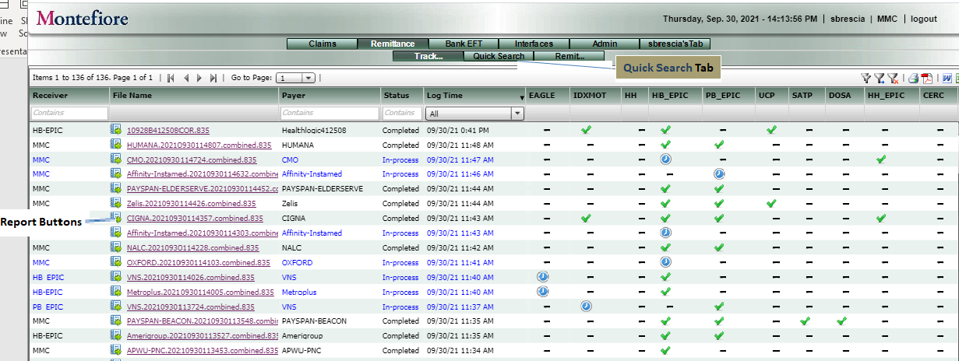

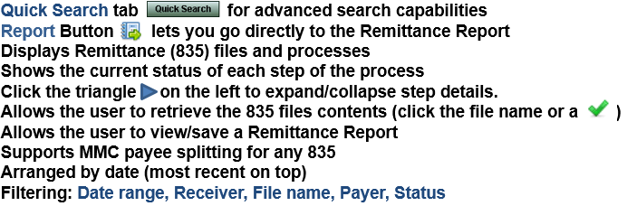

# The Remits Tab (continued) Quick Search Sub-Tab

#### Example Screen:

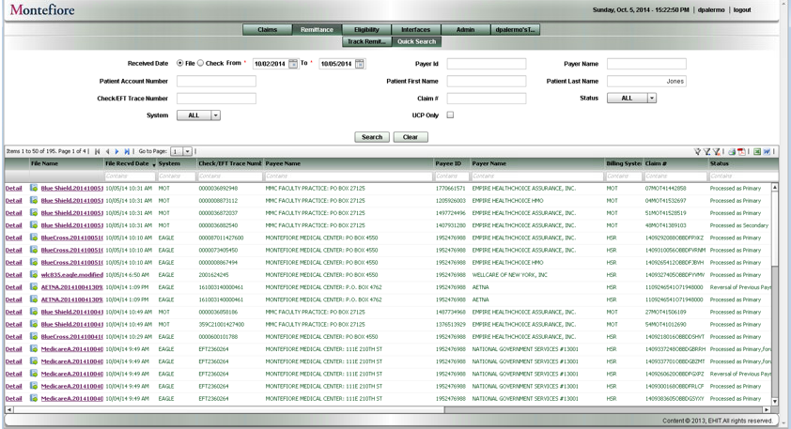

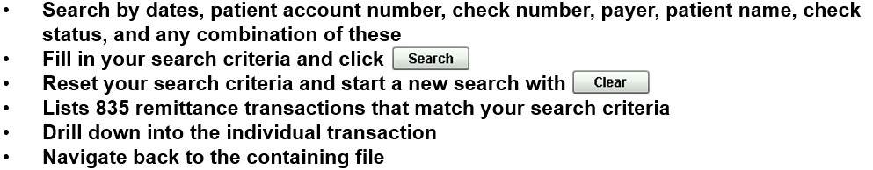

#### The Remittance File Viewer

#### Example Screen:

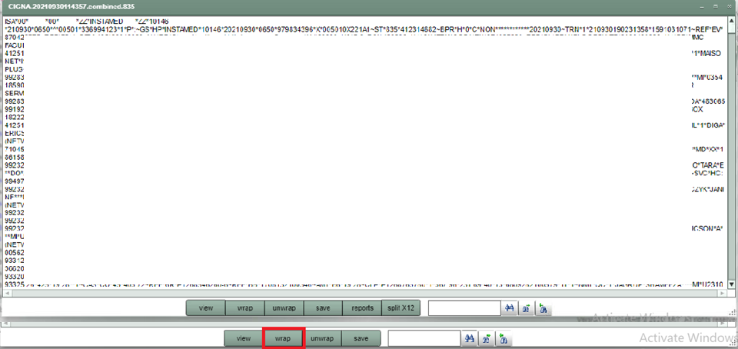

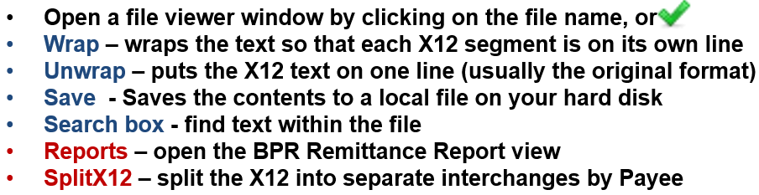

#### The Remittance Split X12 View

#### Example Screen:

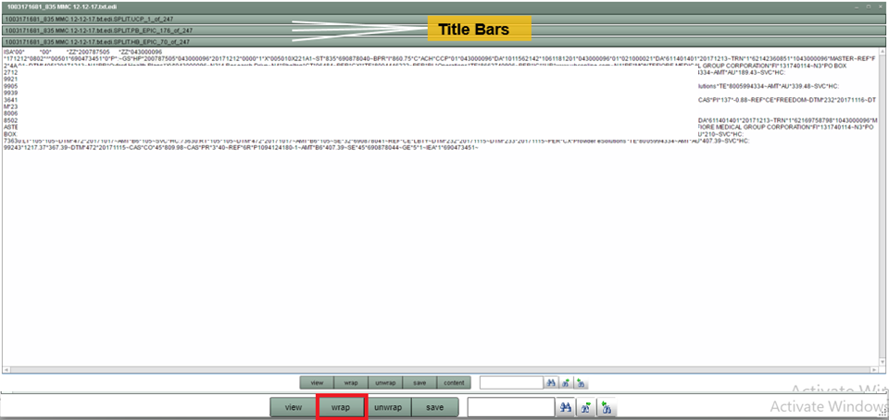

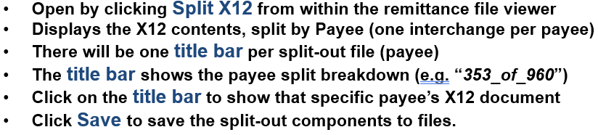

#### The Remittance Report

#### Example Screen:

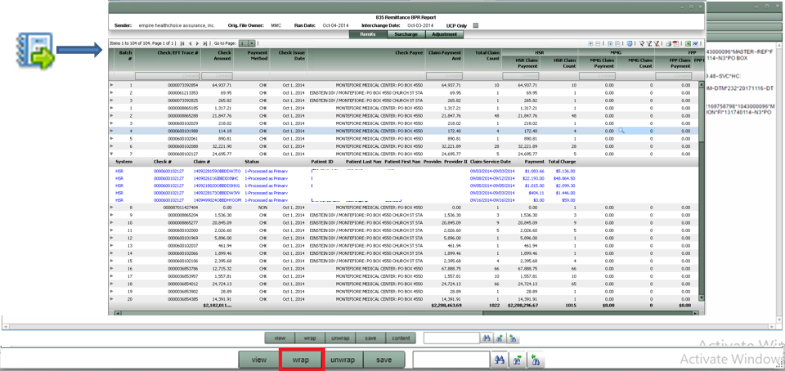

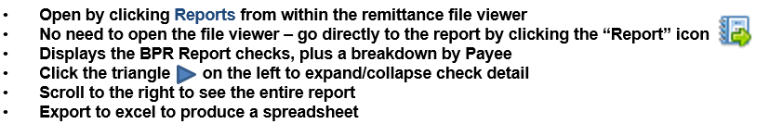

# Bank EFT Tab

#### Example Screen:

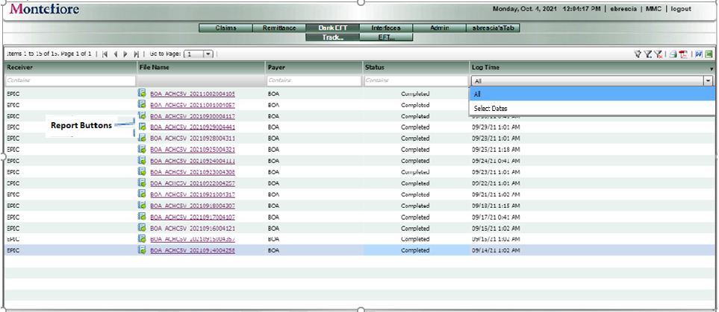

 

#### The EFT Tab File Viewer

#### Example Screen:

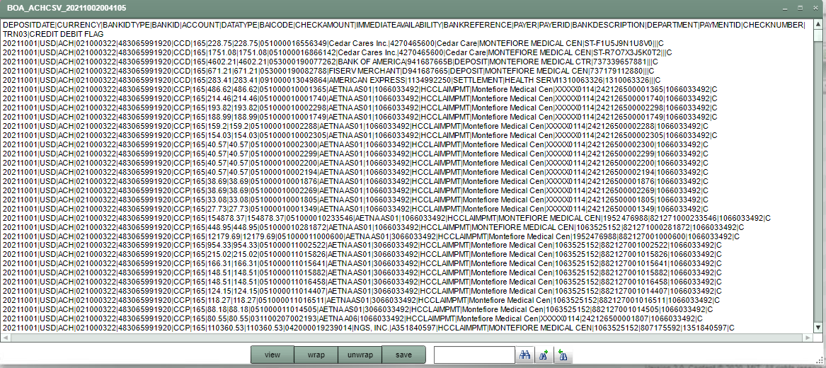



**\*Wrap and Unwrap do not work for EFT Files**

#### The EFT Report

#### Example Screen:

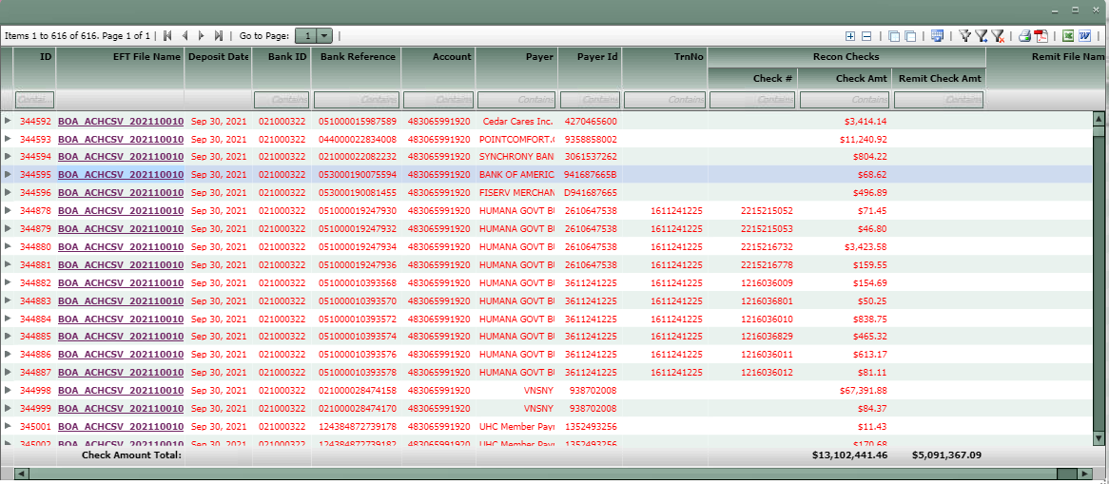

**Displays EFT Report Details**

# The EFT Tab (continued) Quick Search Sub-Tab

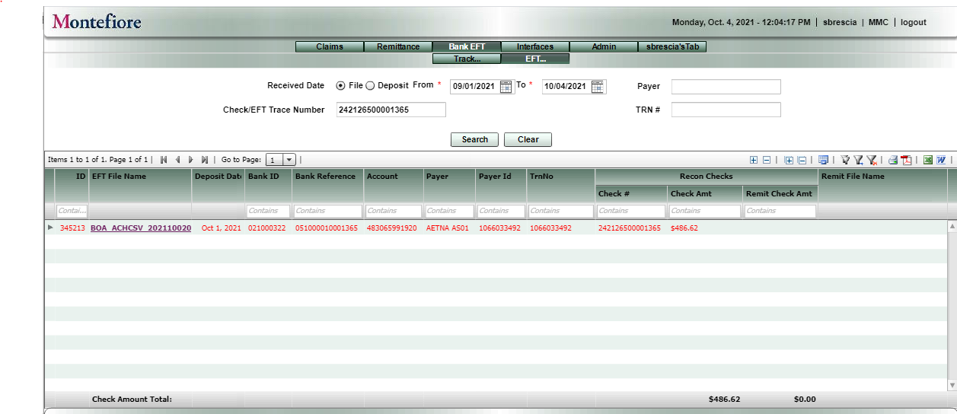

**Search for an individual EFT by Check/EFT Trace Number, Payer or TRN #**

# Interfaces Tab

#### Example Screen:

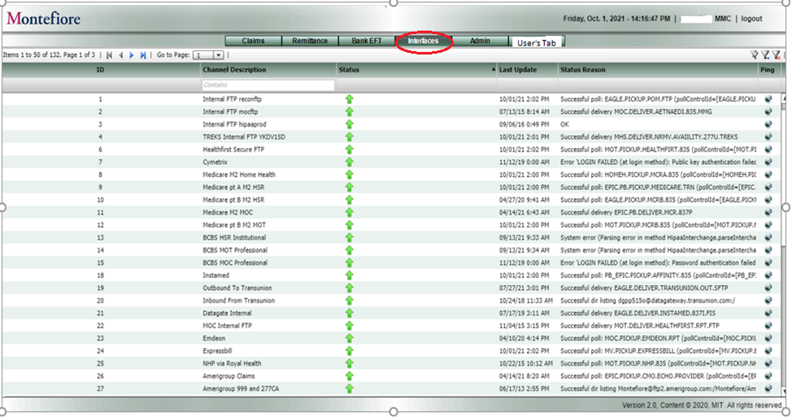

# Admin Step - Admin -> Dispatch Poll

#### Example Screen:

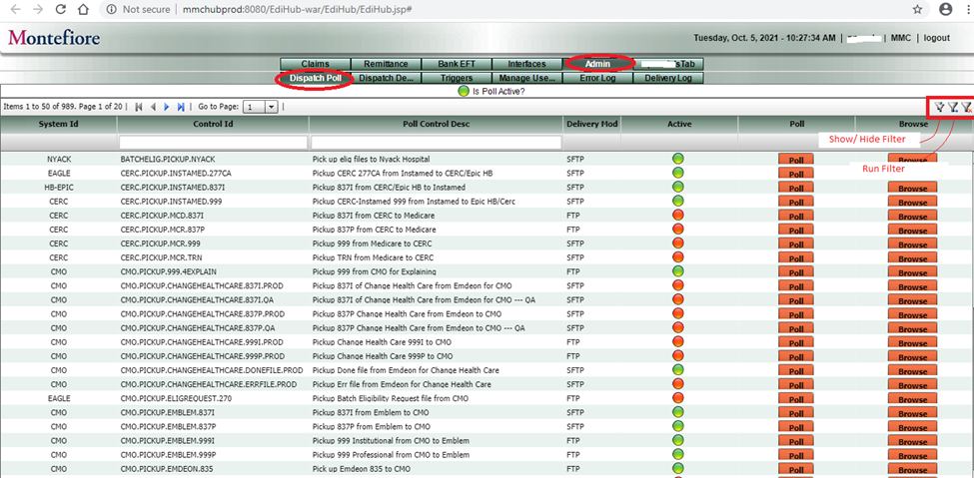

# Admin Step - Admin -> Dispatch Delivery

Example Screen 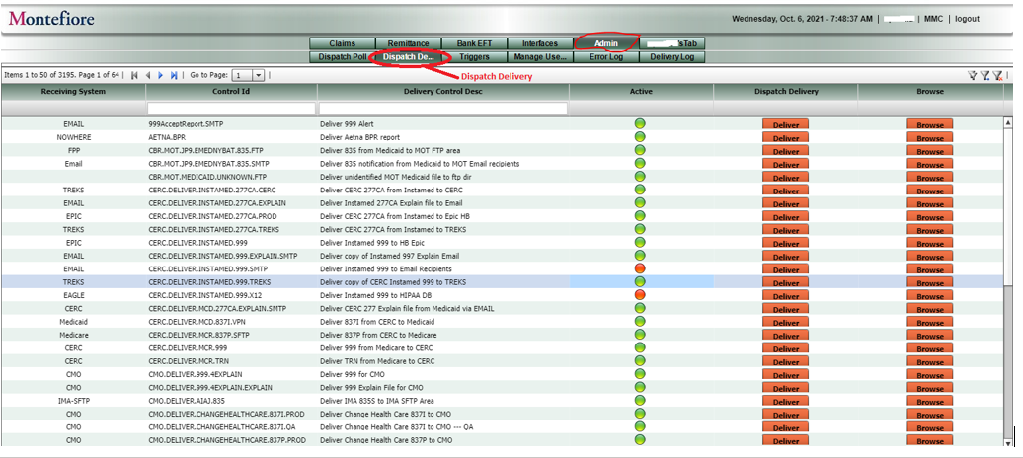

# Admin Step - Admin -> Triggers

Example Screen

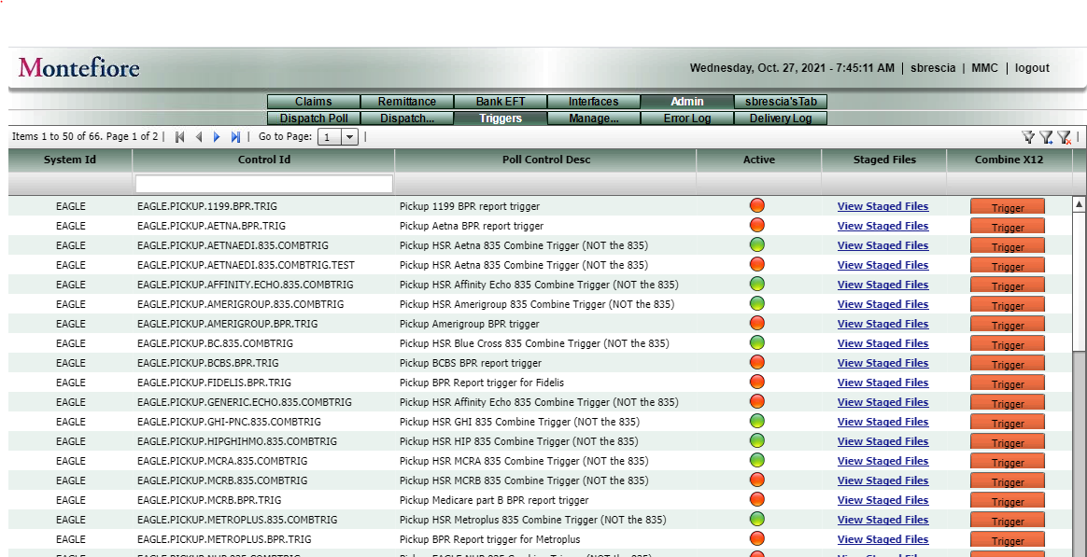

# Admin Step - Admin -> Manage Users

Example Screen

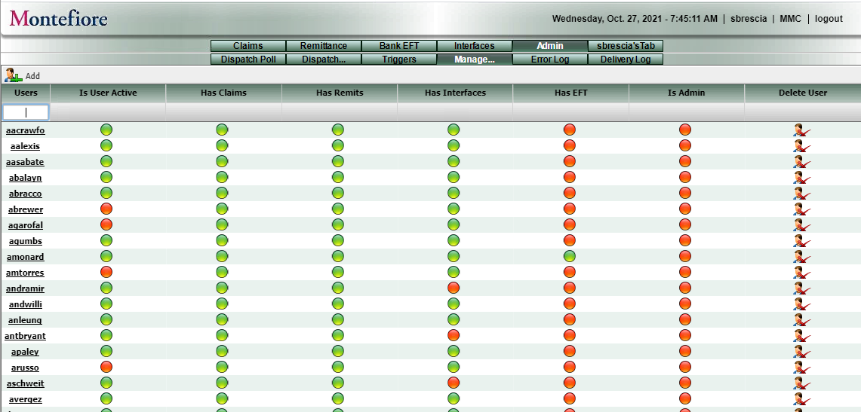

# Admin Step - Admin -> Error Log

Example Screen

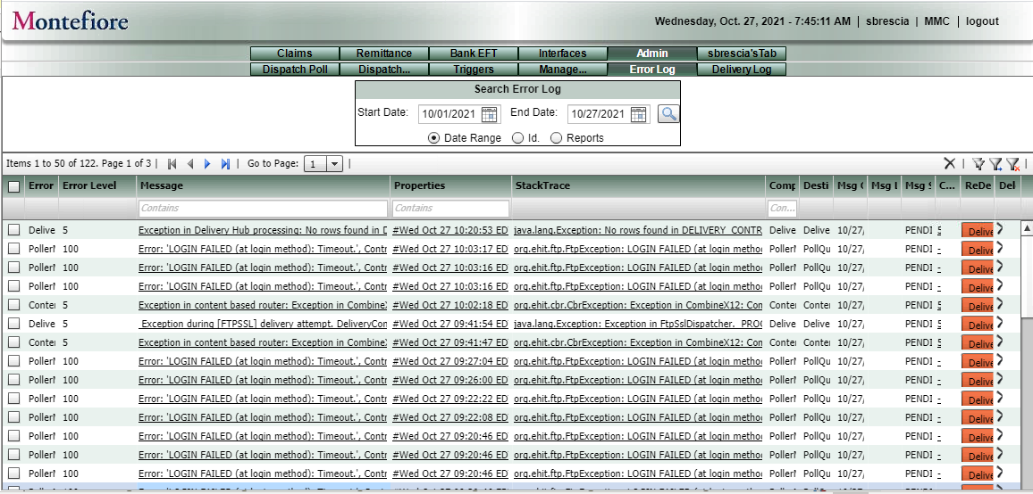

# Admin Step - Admin -> Delivery Log

Example Screen

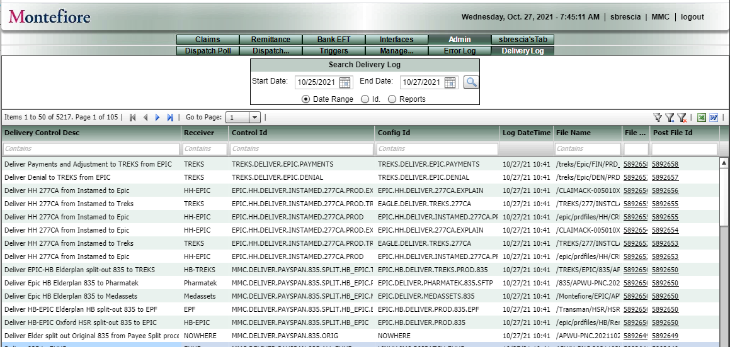

# Admin Step - User’s Tab

#### Example Screen:

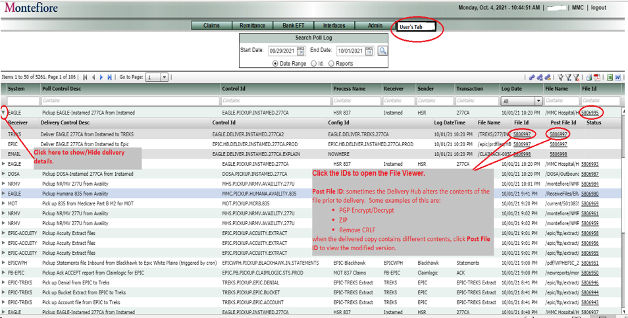

* **Displays every Delivery Hub Pick-up**
* **Links each pick-up with its associated deliveries.**
* **Shows the date/time of every pick-up and delivery**
* **Supports the same file view / save / reports as the other tabs.**
* **Click the triangle on the left to show/hide the delivery details**
* **Each delivery is initially marked “Pending”, and then “Complete” when all expected deliveries are completed successfully**
* **Customized filters**

# Admin – Customize you User Tab

# 

